EXPRESSION OF INTEREST
Future use of the former Meander Primary School

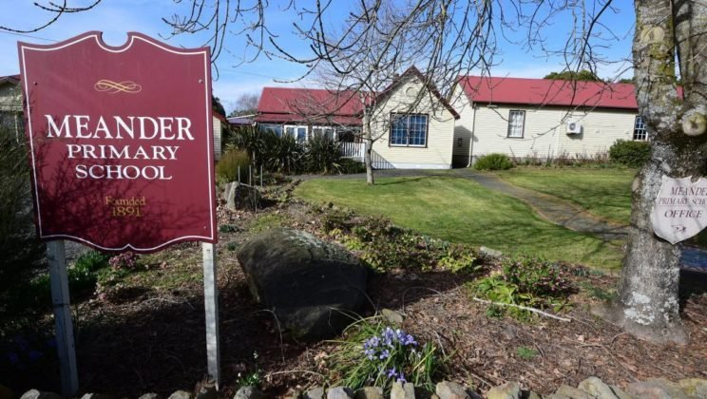
Invitation closes at 2pm, Wednesday 16 February, 2022

- CONTACT INFORMATION
All enquiries regarding this document are to be directed to Melissa Lewarn as per the details below.

Contact Details: Melissa Lewarn - Director, Community Wellbeing
Phone 03 6393 5368
Email: Melissa.lewarn@mvc.tas.gov.au

- INTRODUCTION
Purpose of Expressions of Interest
The Meander Valley Council is seeking submissions from parties interested in establishing a community purpose use for the former Meander Primary School, 137 Main Road, Meander.
Council recognises and respects the diverse range of views and sentiments towards the former primary school that exist within our community. We have been working hard to determine the qualities, attributes and future management scenarios that best represent broad community support and are self-sustaining.
It is our hope that together, we can explore all the possibilities the former Meander Primary School site offers us and find a solution that will benefit our community into the future.

History
The Meander Primary School was founded in 1891. During the 1930s and 1940s, the regional importance of the school increased as nearby schools closed with some of the buildings being relocated to Meander.

The school became an important part of the fabric of the rural community and many residents now reminisce about the key role the school played in their early childhood.

The school closed voluntarily at the end of the 2014 school year after a decline in enrolments. The Tasmanian Government offered the site to the Council in 2015 with the stipulation that the site must not be used for commercial enterprises.

Since 2015, the site has been temporarily occupied and is currently being used by the Deloraine High School for two ten-week pilot education programs which conclude in December 2021.

- MANDATORY INFORMATION FOR EOI RESPONSE
The Expression of Interest is to be presented as a full business case for the future use of the former Meander Primary School site. The following mandatory information should be included on the template provided:
- The legal entity to which the site will be leased;
- Proposed use of the site including the short and long term social benefits to the Meander Valley municipality;
- Proposed measures to fund ongoing maintenance, management and refurbishment of the site including evidence of equity finance to deliver the proposal and funds required from other sources;
- The area required for the proposal – whether part or the whole premises will be required;
- Proposed lease duration;
- Proposed governance, operation and management of the site;
- Any proposed modifications required on the premises to undertake the proposal;
- Any proposed third-party use of the site and public health and safety measures required;
- Administration and management of any sub-tenants;
- Any assistance required from Council;
- Any financial contributions required from other sources;
- Proposed community uses for the site which align with community aspirations;
- Details of previous experience with site or facility management.

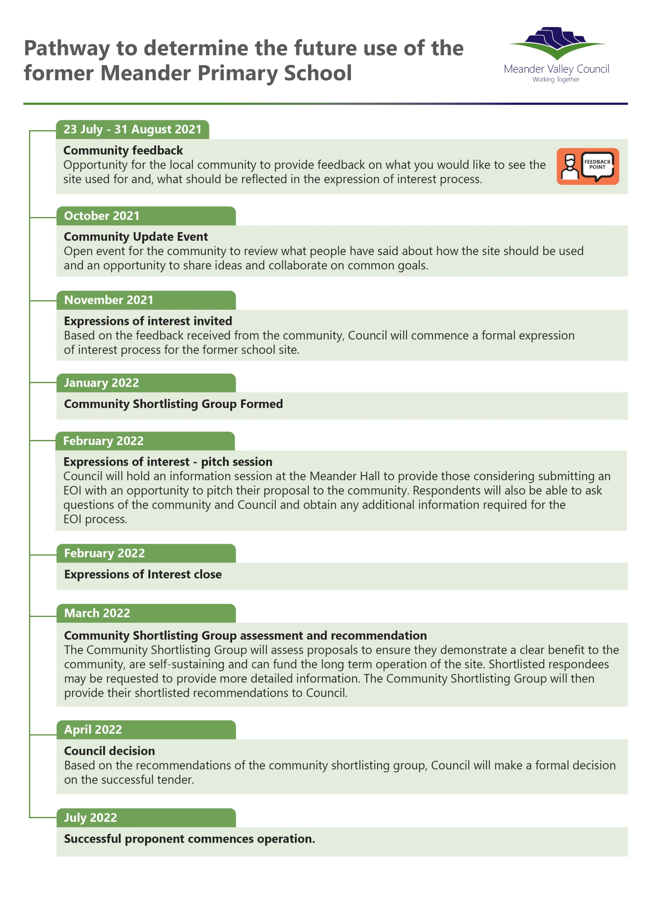
Timeline

Lodgement Details
Expressions of Interest are to be emailed to: tenders@mvc.tas.gov.au by 2pm, Wednesday, 16 February, 2022.
Community Shortlisting Group
Council wants representatives from the Meander community to help us decide the future of the former Meander Primary School.
To ensure the process is manageable, there will be a limit of ten positions on the Community Shortlisting Group (CSG). Six nominated from community organisations and four individual positions.
As the work of the CSG is part of a formal process, members will be required to respect the confidentiality of the progress and also to declare any conflict of interest.
A separate terms of reference will describe the function of the CSG.
Evaluation Criteria
The Community Shortlisting Group will evaluate each Expression of Interest against the following criteria:

- Clear and achievable social benefits to the community;
- Fit with community expectations and aspirations for the site;
- Capacity to deliver the proposal and fund ongoing maintenance, management and refurbishment of the site;
- The extent to which the proposed use is self-sufficient and limits ongoing costs to ratepayers.

Expression of Interest Pitch Session
Council will hold an information session at the Meander Hall on Wednesday, 2 February, 2022 to provide those considering submitting an Expression of Interest with an opportunity to pitch their proposal to the community. It will also be an opportunity for Respondents to ask questions of the community and Council and obtain any additional information required on the Expression of Interest process.
Site Visit
Council will arrange a site visit to interested parties individually or as a group upon request.

- ASSESSMENT OF EXPRESSIONS OF INTEREST
Post Offer Negotiations
- Council reserves the right to ask for refinement or more information from Respondents;
- Any questions or requests for clarification or further information regarding this invitation or the Expression of Interest process must be submitted to Council in writing at least 5 working days prior to the Expression of Interest closing time;
- Council may make available to other prospective Respondents the details of such a request together with any response;
- Respondents who are shortlisted will be provided with details of lease terms and pre-requisite steps depending on the nature of the proposal.
Agreement Dependencies
If your Expression of Interest is shortlisted, you will be required to confirm a willingness and ability to obtain public liability, building and contents and other relevent insurances applicable to the proposed use.
Before execution of any lease, certificates of insurance must be provided to Council:
- Certificate of currency for Public Liability Insurance (min, $20M) and Workers Compensation;
- WHS Policy, WHS Statement or Safety Management System Plan.

- MANDATORY THINGS TO CONSIDER
- Respondents must demonstrate a Community Purpose

The site is subject to a Reversionary Covenant which was put in place by the Tasmanian Government when the property was transferred to Council ownership. This restricts use of the site to a community purpose.

Community purpose is a broad term and should not be considered limiting. As a guide, for the purpose of this Expression of Interest, a ‘community purpose’ may be defined as activities that:

- Encourage a vibrant, engaged and resilient community;
- Build on the strengths of the local or broader community;
- Value and promote local collaborative partnerships;
- Encourage participation in community life and foster social cohesion;
- Contribute to the wellbeing of the community or people with a disadvantage; or
- Extends the benefits of social enterprises delivering not for profit outcomes in response to community needs.

It is accepted by Council that community purpose outcomes may be achieved through operation of not-for-profit social enterprises. The Tasmanian Government has indicated that a commercial or mixed-use option for the school is unlikely to be supported. This aside, where there is a compelling case and clear community benefit, Council may, at its sole discretion, seek consent for a social enterprise use for the site from the Tasmanian Government. Any respondent seeking such action must provide letters of support from community beneficiaries or relevant government agencies.

Operation of a profit-based business entity where benefits are directed to private or commercial interests will not be supported. Considering the above, respondents to the EOI must clearly demonstrate how their proposal satisfies the community purpose requirement.

- Respondents must demonstrate a capacity to maintain the site and facilities and to operate independently of Council

Council may consider a contribution of financial or in-kind assistance to support the initial establishment of an activity or use of the site. However, Council is seeking a lease and management arrangement that is not reliant on ongoing financial or resource support from Council. Respondents must be clear on:

- Their financial circumstance and capacity to sustain ongoing funds to maintain the facility and approved activities;
- The amount and duration (if ongoing funds or in kind support is needed) of any contributions required from Council; and
- How they intend to resource the proposed use and maintenance, for example through paid employees, community volunteers, etc.

- Legal and governance arrangements must be clear

Any successful proposal will be required to enter into a lease or other appropriate legal arrangement with Council. Any assumptions or reliance on sub-leasing must also be clearly stated.

Respondents must be clear on the proposed entity and operating arrangement and how responsibilities and obligations such as employee entitlements, workers compensation and insurance are to be managed.

Where there is an expectation that Council would cover these costs or provide a management structure (for example a Special Committee of Council or Community Hall Committee) this should be clearly described.

- Respondents are expected to engage with the broad community

Respondents are expected to understand and consult with the community.

Council is committed to ensuring the local community is involved in the process of determining the former school’s long term future. Our goal is to find a use for the site that will enhance our community without significant ongoing cost to ratepayers.

Council organised two community consultation sessions in August and October 2021 to gauge feedback and ideas on future use options. The consultation sessions were well attended and the community identified four main future use themes:

- Community Hub;
- Education and Learning;
- Community Services; and
- Tourism.

More information on the community ideas and feedback presented at these community consultation sessions is presented in Appendix A.

- BACKGROUND FOR RESPONDENTS
Infrastructure and assets
A site map indicating the infrastructure on the site is presented as Attachment A. Council expects respondents to accept responsibility for the security and upkeep of all the facilities and grounds under standard lease provisions.
Respondents should be clear if they intend to make use of all or part of the site; clearly indicating what areas and facilities are required. Any proposed improvements on the site must also be identified.
Site condition summary
A condition summary is presented as Attachment B. While currently in use and operational, the site does require some immediate and medium term maintenance. Respondents should factor this into their proposal in terms of cost and resources. Where there is an expectation of a contribution from Council or others; this should be made clear.
Respondents will also be required to cover annual site costs (based on 2020-21) as follows:
- Rates $120.32
- Electricity $326.32
- Land Tax $1457.25
- Insurance costs for 2021: $3,754.74
Land ownership, tenure and planning
A statement of relevant planning scheme arrangements is presented as Attachment C. Respondents will be required to clarify the specifics relating to their proposal with Council’s planning department.

EXPRESSION OF INTEREST FORM
Respondent’s Information
Trading name:
Registered name:
Australian Business Number: | Date of issue:
Address of registered office:
Postal address:
(if different to above):
Principal office in Tasmania
(if applicable):
Email:

Contact Details
Name of contact person:
Position title:
Email:
Telephone number: |  | Mobile:

Lease Details (Please tick)
Proposed Lease Timeframe
3 year
5 year
10 year
Other __________________
Proposed operation
Legal entity
Association
Special Committee of Council
Provide more detail here_____________________________________________________________________
Indicate which part of the site you are proposing to use
All site
Part site
If part site, please specify which areas are required (refer to Attachment A site map) __________________________________________
Financial Capacity (Please tick)
Cash at Bank
Amount held for this project ______________________________
Grant Reliant
Grant Amount required____________________________________
Pitch your Proposal
Describe your proposal and the benefits it will bring to the Meander Valley municipality.

Community Aspirations
Provide a brief description on how your proposal aligns with community aspirations.

Previous Experience
Enter details below to show previous experience with site or facility management.

Referee Details
Provide details below for at least 2 referees
Name of referee (1):
Project:
Contact Telephone
Name of referee (2):
Project:
Contact Telephone

Signed for and on behalf of the respondent
I warrant that in submitting this Expression of Interest response, I have read and accept the conditions of the EOI.
Name:
Position:
Signature:
Date:

